CRTC INTERCONNECTION STEERING COMMITTEE
CONTRIBUTION FORM:
Working Group: CSCN Date of Submission: 2024-05-02
Contribution #: 238B
TIF #: 118 File ID: CNCO238B
Task Title: Update CSCN-Returning TB Return Exception
Related to Task(s) ID: 117, 119, 120
Contributor:
Name: Karen Robinson
Company: KROB Telecom Numbering Solutions
Address:
Tel:
Fax:
E-mail:
Distribution to: CSCN
Subject: Thousands Block Return Exception

Thousands Block Return Exception

There are some SP that consume a large amount of NXX’s to meet business their needs in NPA’s
Returning TB’s that are less than 75% utilized could result in a SP being unable to maintain capacity demand thresholds.

HIGH LEVEL analysis
In the example provided, OCN 8086 is the highest consumer of BC’s NXX with an average of 37 new NXX’s each year.
Hypothetically: Should OCN 8086 have to return 380 TB’s (with zero utilization = 380,000 TN’s) with a utilization less than 75%, it would exceed their one-year capacity threshold of 370 TB (= 370,000 TN’s)

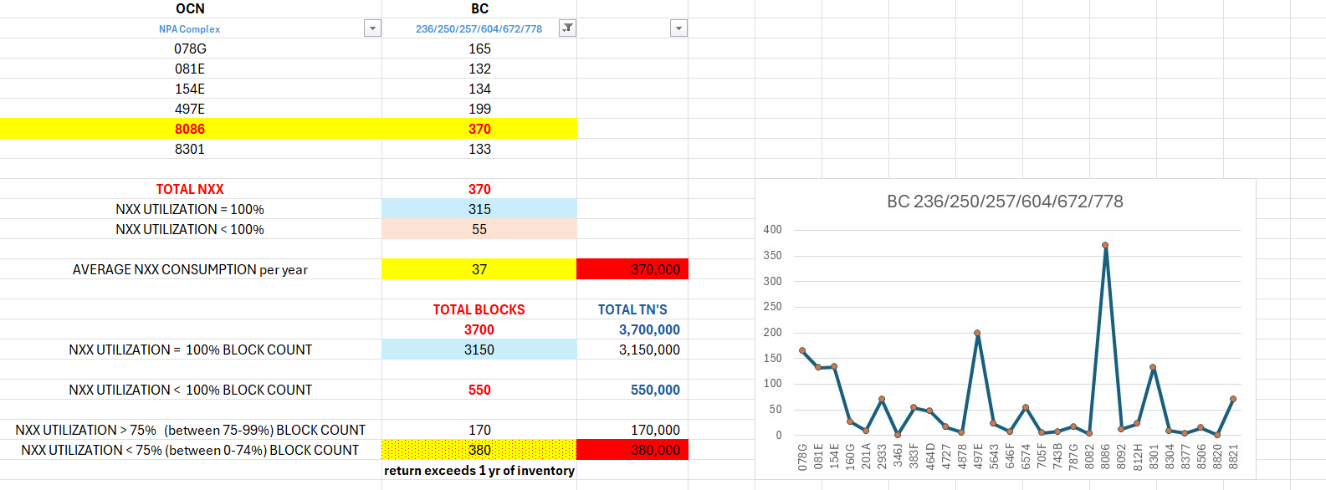

Proposal: Create a scale/formula that identifies SP’s consumption trends highlighting capacity thresholds requiring 12 mth, 9 mth and 6 mth or less of numbering inventory to meet business needs.

